Question 1 : What is Data Loading in Power BI and why is it considered the first step of analysis?
Ans.
Data Loading is the process of importing data from different sources (Excel, SQL, CSV, Cloud, etc.) into Power BI so it can be transformed, modeled, and analyzed.
It happens using:
- Get Data
- Power Query (before loading into the model)

✅ Why is it considered the first step of analysis?
1️⃣ Foundation of Reporting
- No data → No analysis.
2️⃣ Data Structure Setup
- Defines tables, columns, and relationships.
3️⃣ Data Quality Check Starts Here
- Errors, duplicates, missing values are identified during loading.
4️⃣ Performance Impact
- Correct loading method (Import/DirectQuery) affects dashboard speed.

Question 2 : Explain the difference between “Load” and “Transform Data” in Power BI.
Ans.

Difference Between Load and Transform Data in Power BI
🔹 1️⃣ Load
- Directly imports data into the Power BI data model.
- No changes are made before loading.
- Used when data is already clean.
👉 Fast but risky if data has errors.

🔹 2️⃣ Transform Data
- Opens Power Query Editor.
- Allows you to:
  - Clean data
  - Remove duplicates
  - Handle NULLs
  - Change data types
  - Split/merge columns
👉 Used for data cleaning before loading into the model.

Question 3 : What is a Fact Table and a Dimension Table? Give examples from the dataset.
Ans.
1️⃣ Fact Table
A Fact Table contains measurable, numerical data used for analysis.
Characteristics:
- Contains metrics (Price, Sales, Quantity, Revenue)
- Usually large in size
- Connected to dimension tables via keys
👉 Example (from Real Estate dataset):
Real_Estate_Sales
- Property_ID
- Price
- Area_sqft
- Bedrooms
- Bathrooms
Here, Price and Area_sqft are measurable values → so this is the Fact Table.

2️⃣ Dimension Table
A Dimension Table contains descriptive information used to categorize facts.
Characteristics:
- Contains text/category fields
- Smaller in size
- Used for filtering and grouping
👉 Example:
City_Dimension
- City_ID
- City_Name
Owner_Dimension
- Owner_ID
- Owner_Name
These tables describe the facts (sales).

Question 4 : Why is Star Schema preferred over Snowflake Schema in Power BI?
Ans.
Why Star Schema is Preferred over Snowflake Schema in Power BI
1️⃣ Better Performance
- Star schema has fewer joins.
- Faster query execution in Power BI.

2️⃣ Simpler Data Model
- Easy to understand and manage.
- One central Fact table connected directly to Dimension tables.

3️⃣ Easier DAX Calculations
- Relationships are straightforward.
- Reduces ambiguity and filter confusion.

4️⃣ Improved Report Performance
- Optimized for BI tools like Power BI.
- Better compression in VertiPaq engine.

Question 5 : Identify and remove duplicate records based on Date, Country, and State.
Ans.
Remove Duplicates in Power BI (Based on Date, Country, State)
🔹 Step 1: Open Power Query
- Click Home → Transform Data
🔹 Step 2: Select Columns
- Hold Ctrl and select:
  - Date
  - Country
  - State
🔹 Step 3: Remove Duplicates
- Go to Home tab → Remove Rows → Remove Duplicates

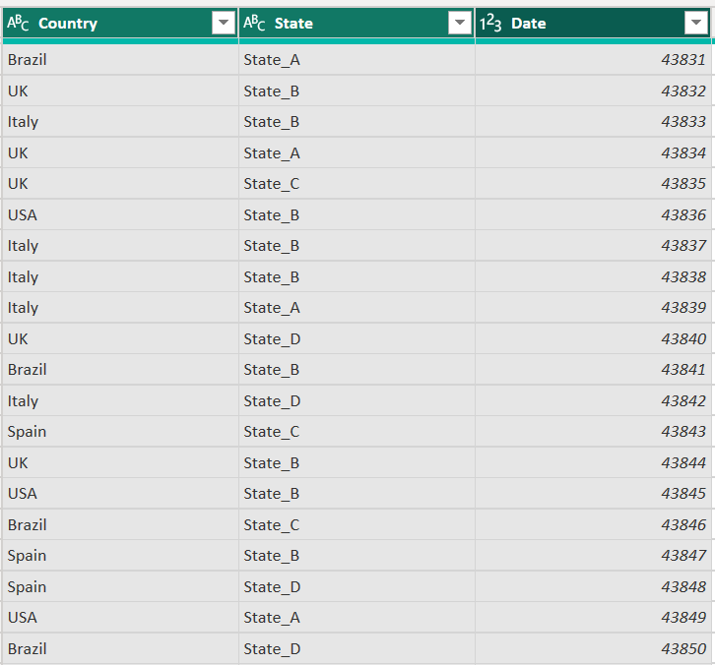

Question 6 : Identify and replace null values in Vaccination_Status.
Ans.
Step 1: Open Power Query
Home → Transform Data

🔹 Step 2: Identify Null Values
- Click the filter dropdown on Vaccination_Status
- Check if (null) appears
- We can filter to see only null records

🔹 Step 3: Replace Null Values
Method 1
- Select Vaccination_Status
- Go to Transform → Replace Values
- Replace: null
- With: ("Not Available")

Question 7 : Create a new column to calculate Recovery Rate.
Ans.
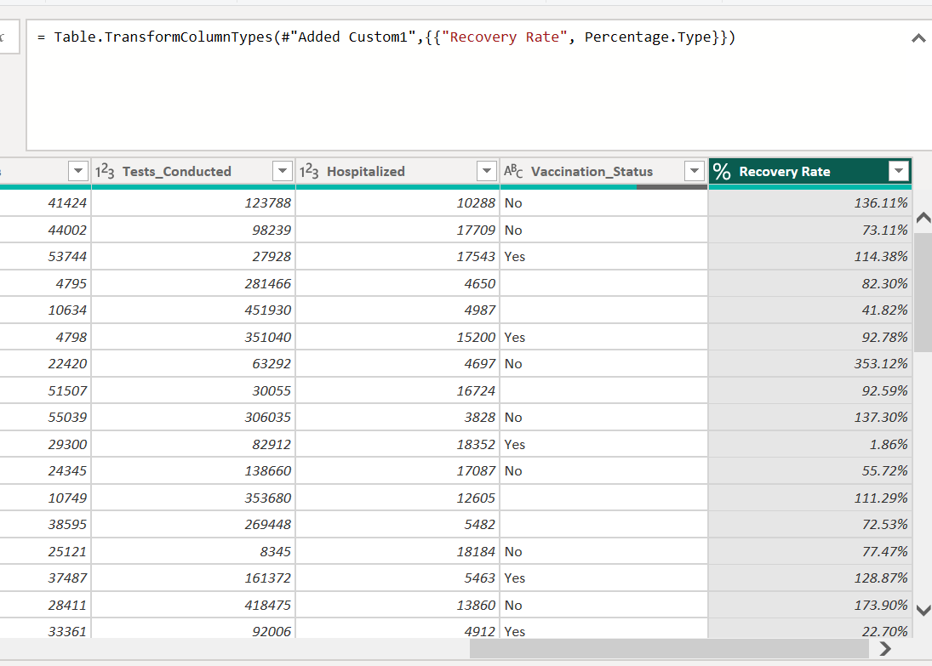

Question 8 : Create a summarized table showing total confirmed cases by Country.
Ans.
